COMPUTATIONAL MODELS OF PROJECTILE MOTION
A documentation of the code written for 2024 British Physics Olympiad Computational challenge
Aliyan Amin
11/08/2024

Abstract
The British Physics Olympiad Computational Challenge of 2024 focused on various models of projectile motion. These includes a simple drag-free model, a more exact analytic model, trajectories that pass through a fixed position, the maximisation of the range of a projectile, the bounding parabola, the length of the distance travelled through the inverted parabolic arc, the variation of the range with the launch angle and time, a bouncing ball, and a model that incorporates drag in two dimensions. An iterative form of the Verlet algorithm is compared with an array of equally spaced elements and the use of numerical integration. Contrary to initial expectations, it has been found that an iterative form of the Verlet algorithm is easier to program, test, and debug, and is in general more effective.
Introduction:
The aim of this paper is to document the code I have written for the British Physics Olympiad Computational Challenge for 2024. The nine programs were originally written in Octave, but are written in pseudocode here. The theory behind much of these programs were soured from Dr French’s website. For each challenge, there is a description of the challenge, an explanation of any key points in the code and the graphs that the codes produce. The original code is included in the appendix.
Challenge 1:
- $θ$ = INPUT “Enter an angle between 0 and 90 degrees”
- $u$ = INPUT “Enter initial speed”
- $h$ = INPUT "Enter launch height”
- $g$ = 9.81
- $a = ucosθ$
- $b = usinθ$
- c = $\frac{b + \sqrt{b^{2} + 2gh}}{g}$
- $t = 0:0.2:c$
- $x = at$
- $y = h + bt - \frac{1}{2}gt^{2}$
- plot($x, y$)
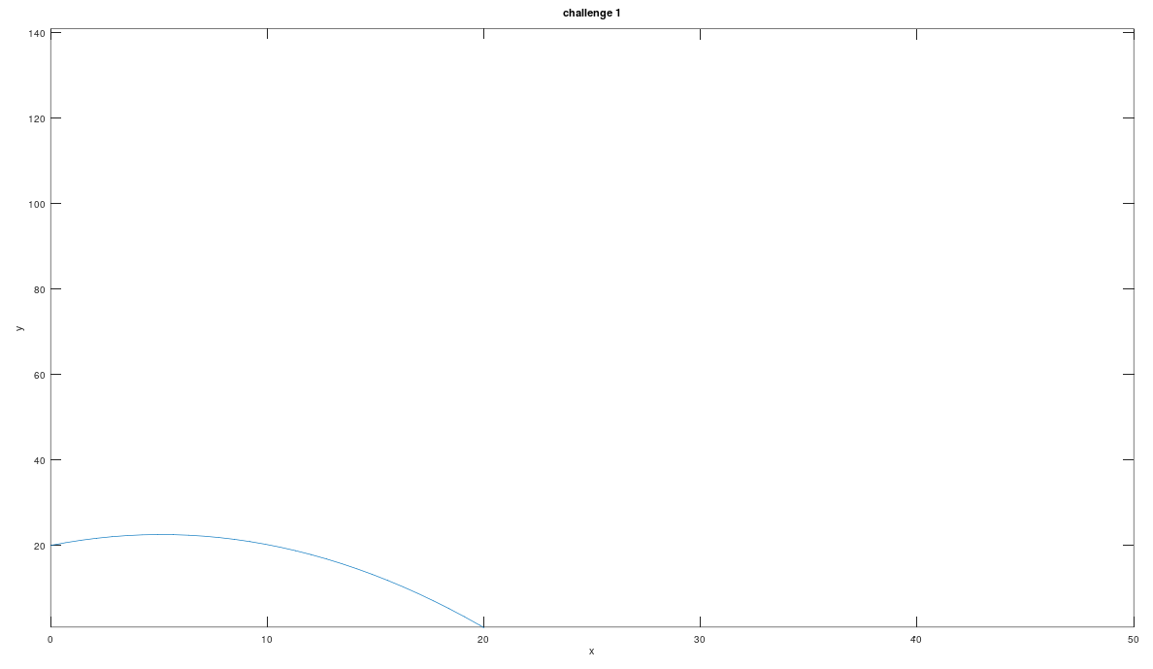
Lines (5) and (6) there to simplify writing out the longer equations in code. Line (7) calculates the time taken for the projectile to land – it is derived from the equation seen in line (10) when $y = 0$. This should hold as long as $h > 0$.

Challenge 2:
- $θ$ = INPUT “Enter an angle between 0 and 90 degrees”
- $u$ = INPUT “Enter initial speed”
- $h$ = INPUT "Enter launch height”
- $g$ = 9.81
- $a$ = sin$θ$
- $b$ = cos$θ$
- $c$ = tan$θ$
- $R = \frac{u^{2}}{g}\left(ab + b\sqrt{a^{2} + \frac{2gh}{u^{2}}}\right)$
- $x$ = linspace($0, R, 1000$)
- $y = h + cx - \frac{g}{2u^{2}}(1 + c^{2})x^{2}$
- $x_{a}= \frac{u^{2}}{g}ab$
- $y_{a}= h + \frac{u^{2}}{2g}a^{2}$
- plot($x, y$, blue)
- plot($x_{a}, y_{a}$, red)
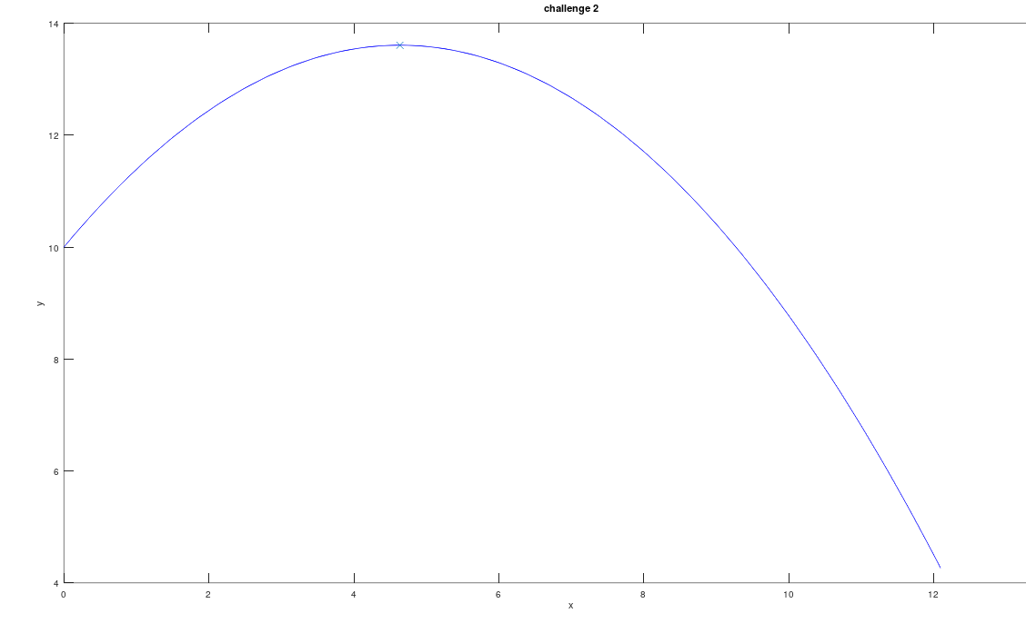
Lines (5), (6), and (7) are written to simplify writing out later equations. In line (9), the fixed interval that x increases by is based on the range of the projectile – this ensures that the program runs for the same amount of time regardless of the inputs.
Challenge 3:
- $X$ = INPUT “Enter the x-coordinate of the target”
- $Y$ = INPUT “Enter the y-coordinate of the target”
- $h$ = INPUT "Enter launch height”
- $g = 9.80665$
- $u = g^{2}(Y + \sqrt{X^{2}+Y^{2}})$
- $a = \frac{g}{2u^{2}}X^{2}$
- $b = -X$
- $c=Y-h+\frac{gX^{2}}{2u^{2}}$
- $t_{+}=\frac{-b+\sqrt{b^{2}-4ac}}{2a}$
- $t_{-}=\frac{-b±\sqrt{b^{2}-4ac}}{2a}$
- $t_{min}=\frac{Y+\sqrt{X^{2}+Y^{2}}}{X}$
- $x$ = linspace($0, X, 1000$)
- $y_{+} = h + t_{+}x - \frac{g}{2u^{2}}(1 + {t_{+}}^{2})x^{2}$
- $y_{-} = h + t_{-}x - \frac{g}{2u^{2}}(1 + {t_{-}}^{2})x^{2}$
- $y_{min} = h + t_{min}x - \frac{g}{2u^{2}}(1 + {t_{min}}^{2})x^{2}$
- plot($x, y_{+}$, red)
- plot($x, y_{-}$, blue)
- plot($x, y_{min}$, red)
Again, the coefficient of the hidden quadratic in terms of $\tan{θ}$ are defined as separate variables to simplify writing out later equations. The $t$ values are tan values of the three different angles, which again, simplifies later equations and also avoids complex numbers being returned.
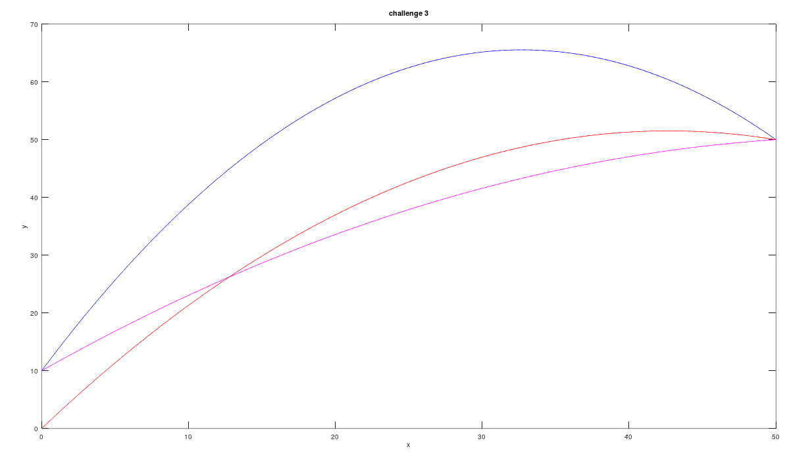

Challenge 4:
- $θ$ = INPUT “Enter an angle between 0 and 90 degrees”
- $u$ = INPUT “Enter initial speed”
- $h$ = INPUT "Enter launch height”
- $g$ = 9.81
- $θ_{max}=\sin^{-1}\left(\frac{1}{\sqrt{2 + \frac{2gh}{u^{2}}}}\right)$
- $a$ = sin$θ$
- $b$ = cos$θ$
- $c$ = tan$θ$
- $a_{max}$ = sin$θ_{max}$
- $b_{max}$ = cos$θ_{max}$
- $c_{max}$ = tan$θ_{max}$
- $R = \frac{u^{2}}{g}\left(ab + b\sqrt{a^{2} + \frac{2gh}{u^{2}}}\right)$
- $R_{max}=\frac{u^{2}}{g}\sqrt{1+\frac{2gh}{u^{2}}}$
- $x$ = linspace($0, R, 1000$)
- $y = h + cx - \frac{g}{2u^{2}}(1 + c^{2})x^{2}$
- $x_{max}$ = linspace($0,{ R}_{max}, 1000$)
- $y_{max} = h + c_{max}x_{max} - \frac{g}{2u^{2}}(1 + {c_{max}}^{2}){x_{max}}^{2}$
- plot(x, y, blue)
- plot($x_{max}$, $y_{max}$, red)
Most of the code from this challenge is a combination of the code from challenges 2 and 3.
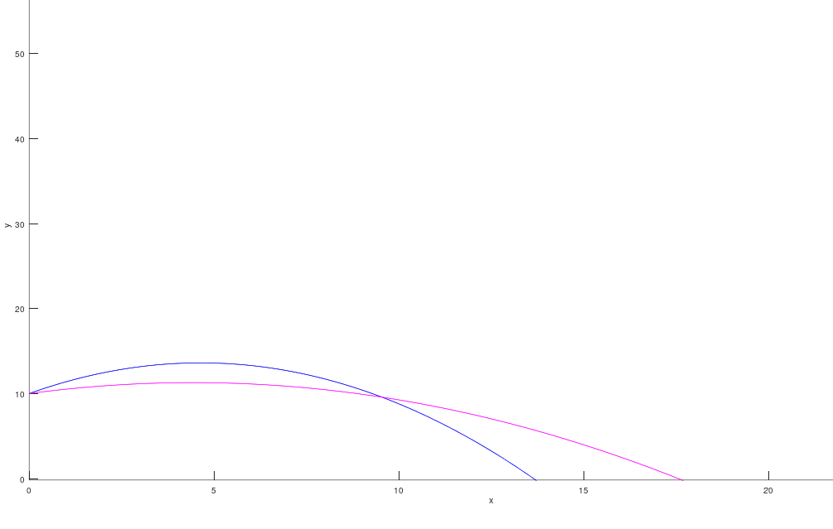
Challenge 5:
- $h$ = INPUT “Enter a launch height”
- $X$ = INPUT “Enter the x-coordinate of your target”
- $Y$ = INPUT “Enter the y-coordinate of your target”
- FUNCTION projectile_plot($v, θ, h$, colour)
  - $Δt = 0.01$
  - $Δx = 0.5$
  - $x = 0$
  - DO UNTIL $y < 0$:
    - $y=h + x\tan{θ} - \frac{g}{2v^{2}}(1 + \tan^{2}{θ})x^{2}$
    - plot($x, y$, colour)
    - $x = x + Δx$
- END FUNCTION
- FUNCTION minimum_trajectory($X, Y$, colour)
  - $x = 0$
  - $Δx=0.5$
  - DO UNTIL y < 0:
    - $y = x\left(\frac{Y+\sqrt{X^{2}+Y^{2}}}{X}\right)-\frac{\sqrt{X^{2}+Y^{2}}}{X^{2}}x^{2}$
    - plot ($x, y$, colour)
    - $x = x + Δx$
- END FUNCTION
- FUNCTION bounding_parabola(v, h, colour):
  - $∆x = 1$
  - $x = 0$
  - DO UNTIL y < 0:
    - $y = h + \frac{v^{2}}{2g}-\frac{g}{2v^{2}}x^{2}$
    - plot($x, y$, colour)
    - $x = x + Δx$
- END FUNCTION
- $u=\sqrt{g\left(Y+\sqrt{X^{2}+Y^{2}}\right)}$
- $a = \frac{g}{2u^{2}}X^{2}$
- $b = -X$
- $c=Y-h+\frac{gX^{2}}{2u^{2}}$
- $θ_{+}=\tan^{-1}\left(\frac{-b+\sqrt{b^{2}-4ac}}{2a}\right)$
- $θ_{-}=\tan^{-1}\left(\frac{-b-\sqrt{b^{2}-4ac}}{2a}\right)$
- $θ_{max}=\sin^{-1}\left(\frac{Y+\sqrt{X^{2}+Y^{2}}}{X}\right)$
- projectile_plot($u, θ_{+}, h$, red)
- projectile_plot($u, θ_{-}, h$, blue)
- projectile_plot($u, θ_{max}, h$, green)
- minimum_trajectory($u, h$, black)
- bounding_parabola($u, h$, purple)
The linspace() function used in previous challenges is replaced by a do until loop that finishes when y < 0. Although it is computationally expensive and takes much longer, this approach produces a more accurate graph. Due to the nature of the equations, different functions are used for the bounding and minimum u parabolas.
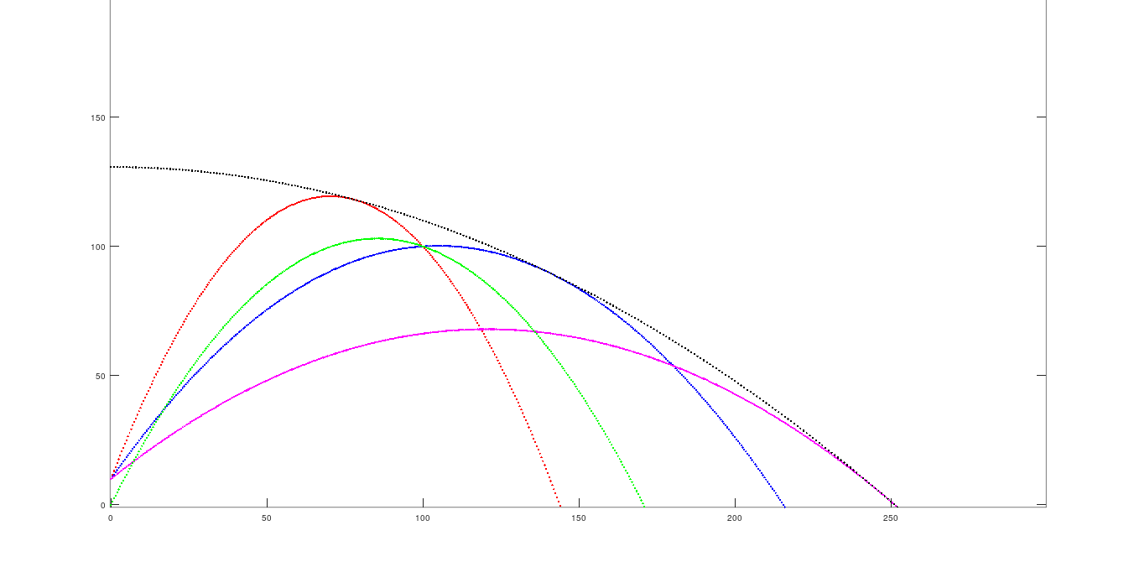
Challenge 6:
- $θ$ = INPUT “Enter an angle between 0 and 90 degrees”
- $u$ = INPUT “Enter initial speed”
- $h$ = INPUT "Enter launch height”
- $a_{x}$ = 0
- $a_{y}$= $-9.81$
- $∆t = 0.01$
- $x = 0$
- $y = h$
- $x_{new}=h$
- $y_{new}= h$
- $s = 0$
- $\sum{s}=0$
- $v_{x}= ucosθ$
- $v_{y}= usinθ$
- DO UNTIL $y < 0$:
  - $v_{x}=v_{x}+a_{x}∆t$
  - $v_{y}=v_{y}+a_{y}∆t$
  - $x = x_{new}$
  - $y = y_{new}$
  - $x_{new}=x+v_{x}∆t+\frac{1}{2}a{(∆t)}^{2}$
  - $y_{new}=y+v_{y}∆t+\frac{1}{2}a{(∆t)}^{2}$
  - $s=\sqrt{{(x_{new}-x)}^{2}{+(y_{new}-y)}^{2}}$
  - $\sum{s=\sum{s+s}}$
  - $plot(x_{new}, y_{new}, red)$
- $θ_{max}=\sin^{-1}\left(\frac{1}{\sqrt{2 + \frac{2gh}{u^{2}}}}\right)$
- $x = 0$
- $y = h$
- $x_{new} = 0$
- $y_{new}= h$
- $s = 0$
- $\sum{s_{max}}=0$
- $v_{x} = ucosθ_{max}$
- $v_{y}= usinθ_{max}$
- DO UNTIL $y < 0$:
  - $v_{x}=v_{x}+a_{x}∆t$
  - $v_{y}=v_{y}+a_{y}∆t$
  - $x = x_{new}$
  - $y = y_{new}$
  - $x_{new}=x+v_{x}∆t+\frac{1}{2}a{(∆t)}^{2}$
  - $y_{new}=y+v_{y}∆t+\frac{1}{2}a{(∆t)}^{2}$
  - $s=\sqrt{{(x_{new}-x)}^{2}{+(y_{new}-y)}^{2}}$
  - $\sum{s_{max}} = \sum{s_{max}}+s$
  - $plot(x_{new}, y_{new}, blue)$
- OUTPUT $\sum{s}$
- OUTPUT $\sum{s_{max}}$
This builds on the code seen in challenge 5, and utilises the Verlet algorithm. Instead of using the integral described in the brief to compute the total distance travelled, an iterative form of Pythagoras’ Theorem is used to compute the total distance travelled. Hence, two new variables, $x_{new}$ and $y_{new}$, are used to calculate the distance between adjacent points. The reason for this was that it was quicker to implement and less prone to errors that using numerical integration.
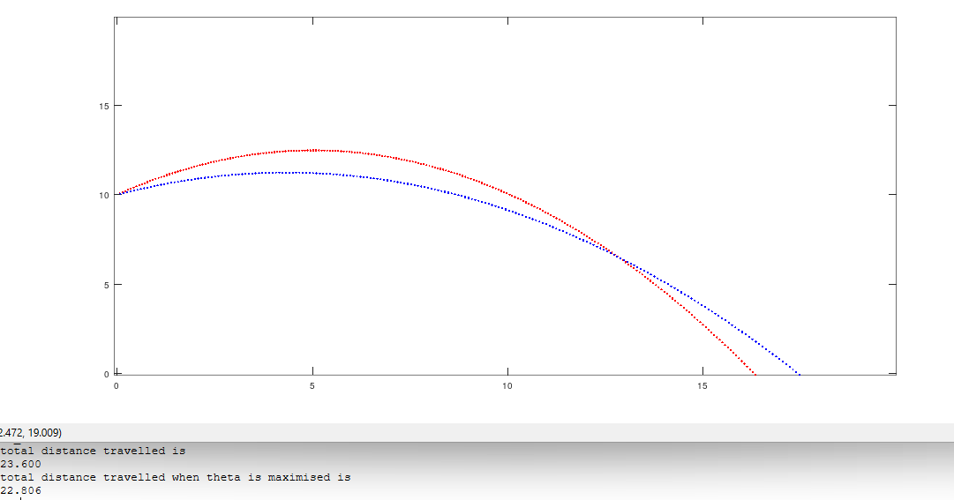
Challenge 7:
- $u$ = INPUT “Enter speed”
- $θ$ = INPUT “Enter an angle from 0 to 90$°$
- g = $-9.81$
- $R = \frac{u^{2}}{g}\left(\sin{θ}\cos{θ}+ \cos{θ}\sqrt{\sin^{2}{θ} + \frac{2gh}{u^{2}}}\right)$
- $T = \frac{R}{u\cos{θ}}$
- $T=$ linspace($0, T,1000$)
- $r = \sqrt{u^{2}t^{2}-gt^{3}u\sin{θ+\frac{1}{4}g^{2}t^{4}}}$
- $t_{+}=\frac{3u}{2g}\sin{θ}+\sqrt{\frac{9u^{2}}{4g^{2}}\sin^{2}{θ-\frac{2u^{2}}{g^{2}}}}$
- $r_{+} = \sqrt{u^{2}{t_{+}}^{2}-g{t_{+}}^{3}u\sin{θ+\frac{1}{4}g^{2}{t_{+}}^{4}}}$
- $t_{-}=\frac{3u}{2g}-\sqrt{\frac{9u^{2}}{4g^{2}}\sin^{2}{θ-\frac{2u^{2}}{g^{2}}}}$
- $r_{-} = \sqrt{u^{2}{t_{-}}^{2}-g{t_{-}}^{3}u\sin{θ+\frac{1}{4}g^{2}{t_{-}}^{4}}}$
- plot($t, r$)
- plot($t_{+}, r_{+}$)
- plot($t_{-}, r_{-}$)
Due the nature of the graphs produced, the linspace() is used instead of the Verlet algorithm.
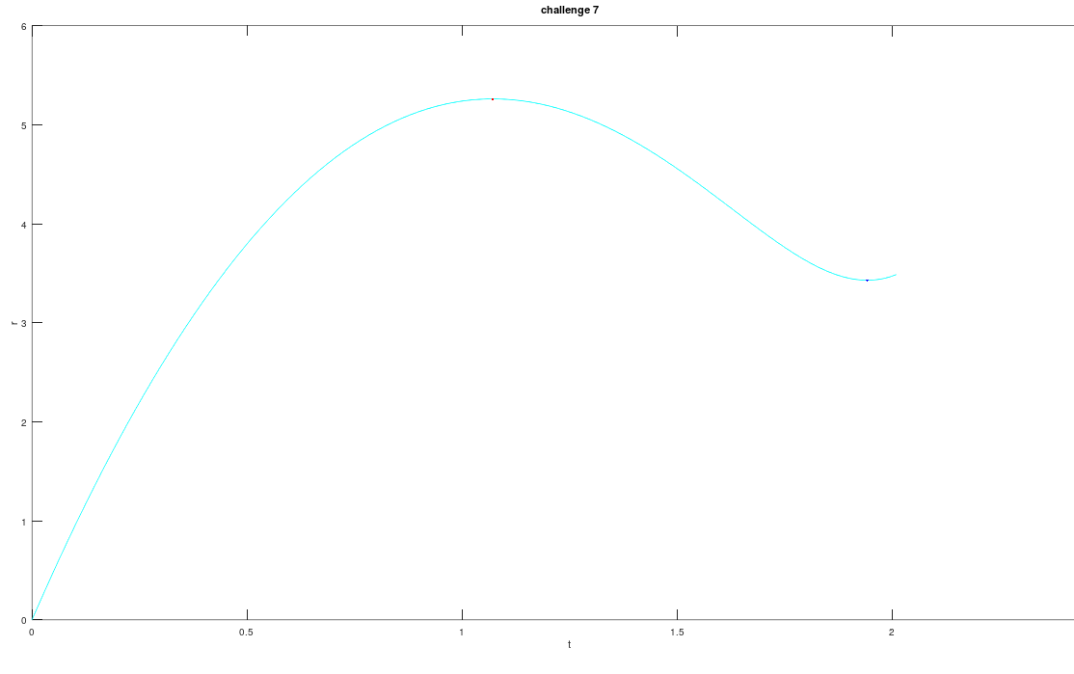
Challenge 8:
- $u$ = INPUT “Enter speed”
- $θ$ = INPUT “Enter an angle from 0 to 90$°$.”
- $h=$ INPUT “Enter the launch angle height.”
- $N=$ INPUT “How many bounces?”
- $c=$ INPUT “What is the coefficient of restitution?”
- $a_{x}= 0$
- $a_{y }=-9.81$
- $n = 0$
- $∆t = 0.01$
- $x = 0$
- $y = h$
- $x_{new} = 0$
- $y_{new}= h$
- $v_{x} = ucosθ$
- $v_{y}= usinθ$
- WHILE $n$ != 0:
  - DO UNTIL $y < 0$:
    - $v_{x}=v_{x}+a_{x}∆t$
    - $v_{y}=v_{y}+a_{y}∆t$
    - $x = x_{new}$
    - $y = y_{new}$
    - $x_{new}=x+v_{x}∆t+\frac{1}{2}a{(∆t)}^{2}$
    - $y_{new}=y+v_{y}∆t+\frac{1}{2}a{(∆t)}^{2}$
    - $plot(x_{new}, y_{new}, red)$
    - pause(1 second)
  - $n = n+1$
  - $y = 0$
  - $u = uc$
  - $v_{x}=u\cos{θ}$
  - $v_{x}=u\sin{θ}$
Code is reused from challenge 6. The do until loop is nested inside a while loop to simulate bouncing.
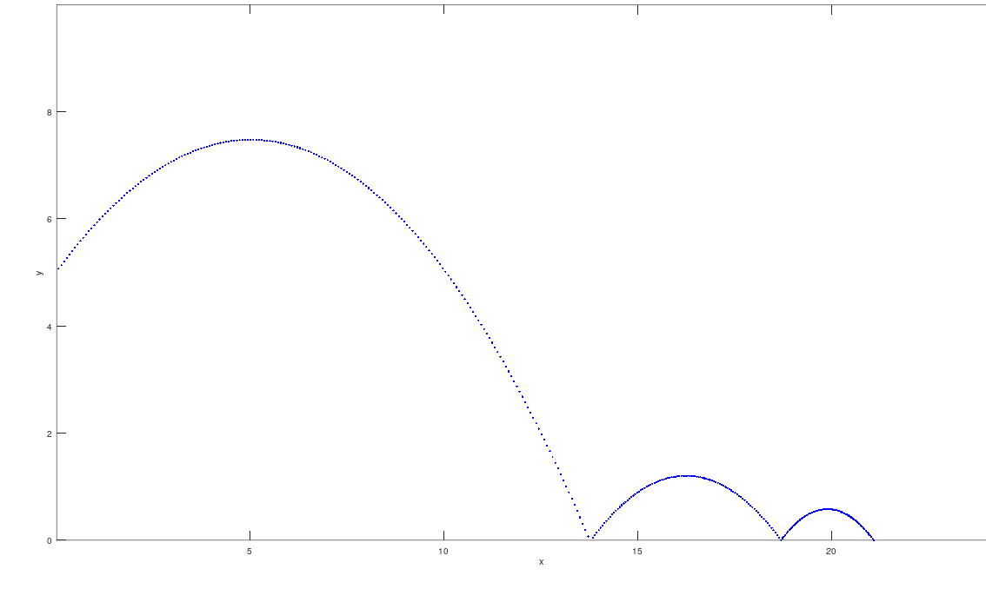

Challenge 9:
- $u$ = INPUT “Enter speed”
- $θ$ = INPUT “Enter an angle from 0 to 90$°$.”
- $h=$ INPUT “Enter the launch angle height.”
- $r=$ INPUT “What is the radius of the projectile?”
- $m=$ INPUT “What is the mass of the projectile?”
- $c_{D}=$ INPUT “What is the drag coefficient?”
- $A=πr^{2}$
- $ρ=1.28$
- $k=\frac{\frac{1}{2}c_{D}ρA}{m}$
- $a_{x}= 0$
- $a_{y }=-9.81$
- $n = 0$
- $∆t = 0.01$
- $x = 0$
- $y = h$
- $x_{new} = 0$
- $y_{new}= h$
- $v_{x} = ucosθ$
- $v_{y}= usinθ$
- DO UNTIL y < 0:
  - $v_{x}=v_{x}+a_{x}∆t$
  - $v_{y}=v_{y}+a_{y}∆t$
  - $x = x_{new}$
  - $y = y_{new}$
  - $x_{new}=x+v_{x}∆t+\frac{1}{2}a{(∆t)}^{2}$
  - $y_{new}=y+v_{y}∆t+\frac{1}{2}a{(∆t)}^{2}$
  - $plot(x_{new}, y_{new}, red)$

- DO UNTIL y < 0:
  - $v_{d}=\sqrt{{v_{x}}^{2}+{v_{y}}^{2}}$
  - $a_{xD}=-\frac{{v_{xD}}^{2}}{v}kv^{2}$
  - $a_{yD}=-g-\frac{{v_{yD}}^{2}}{v_{d}}kv^{2}$
  - $v_{xD}=v_{xD}+a_{xD}∆t$
  - $v_{yD}=v_{yD}+a_{yD}∆t$
  - $x_{D}=x_{D}+v_{xD}∆t+\frac{1}{2}a{(∆t)}^{2}$
  - $y_{D}=y_{D}+v_{yD}∆t+\frac{1}{2}a{(∆t)}^{2}$
  - $plot\left(x_{new},y_{new},red\right)$
For the drag-free graph, code from challenge 8 is copied. For the model that incorporates drag, the acceleration is now also included in the do until loop and varies with each iteration.
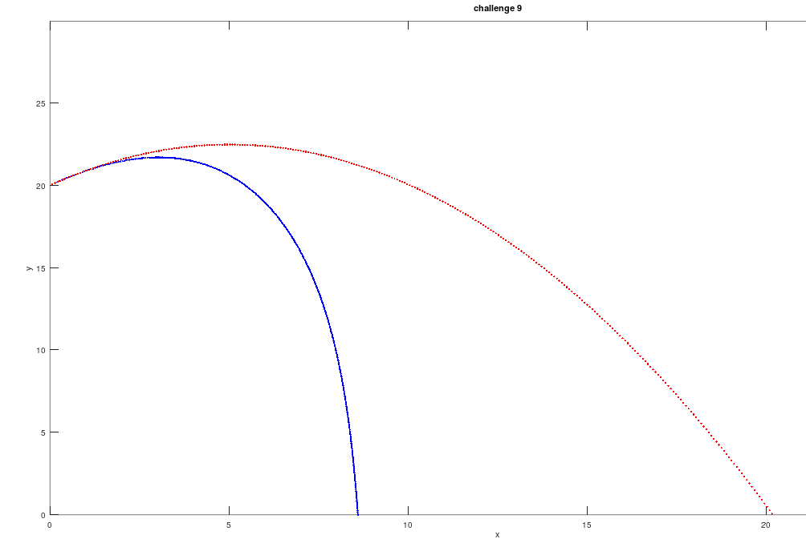

Conclusion:
In sum, this paper has shown how mathematical models of projectile motion can be implemented into a programming language such as Octave. More specifically, it has highlighted the value of using simpler, iterative approaches through loops as opposed to the more complex arrays and numerical calculus that some programming languages offer. This approach has made the implementation of the models faster and easier and has made the results more reliable.

Bibliography
Eclecticon.info. (2024). The Eclecticon of Dr French. [online] Available at: http://www.eclecticon.info/maths%20-%20mechanics.htm [Accessed 11 Aug. 2024].
² Udel.edu. (2022). Computational Methods of Physics. [online] Available at: https://www.physics.udel.edu/~bnikolic/teaching/phys660/numerical_ode/node5.html.

Appendix A – Challenge 1:
theta = input('Enter an angle between 0 and 2*pi radians')
u = input('Enter an initial trajectory speed')
g = input('Enter a value for the strength of gravity')
h = input('Enter a launch height')
a = u*cos(theta)
b = u*sin(theta)
c = (b + (b^2 + 2*g*h)^0.5)/g
t = 0:0.2:c
T = t.^2

do until (y < 0)
y = h + b*t - 0.5*g*(t.^2)
x = a*t

plot(x,y)
xlabel('x')
ylabel('y')
title('challenge 1')

Appendix B – Challenge 2:
theta = input('Enter an angle between 0 and 2*pi radians')
u = input('Enter an initial trajectory speed')
g = input('Enter a value for the strength of gravity')
h = input('Enter a launch height')

a = cos(theta)
b = sin(theta)
c = tan(theta)

R = ((u^2)/g)+(b*a + a*(b^2 + ((2*g*h)/(u^2))))

x = 0:R/1000:R
y = h+(c.*x)-((g/(2*(u^2)))*(1+(c^2))*(x.^2))

x_apogee = ((u^2)/g)*(b*a)
y_apogee = h + ((u^2)/(2*g))*(b^2)

plot(x,y,'b',x_apogee,y_apogee,'m')
xlabel('x')
ylabel('y')
title('challenge 2')

Appendix C - Challenge 3:
X = input('Enter X coordiante of target')
Y = input('Enter Y coordinate of target')
h = input('Enter launch height')
#u = input('Enter launch speed')

g = 9.80665
u = (g^0.5)*(Y+((X^2)+(Y^2))^0.5)^0.5
a = g*(0.5/(u^2))*(X^2)
b = 0-X
c = Y -h + g*(X^2)*(0.5/(u^2))

t1 = (-b + ((b^2)-4*a*c)^0.5)/(2*a)
t2 = (-b - ((b^2)-4*a*c)^0.5)/(2*a)
t3 = ((Y + ((X^2)+(Y^2))^0.5)/X)

x = 0:X/1000:X

y1 = h+ (t1.*x)-((g/(2*(u^2)))*(1+(t1)^2)*(x.^2))
y2 = h+ (t2.*x)-((g/(2*(u^2)))*(1+(t2)^2)*(x.^2))
#y3 = h+(t3.*x)-((g/(2*(u^2)))*(1+(t3)^2)*(x.^2))
y3 = x.*((Y + ((X^2)+(Y^2))^0.5)/X)-((((X^2)+(Y^2))^0.5)/(X^2)).*(x.^2)

plot(x,y1,'b')
hold on
plot(x,y2,'m')
hold on

Appendix D - Challenge 4:
g = input('Enter value for strength of gravity')
u = input('Enter launch speed')
h = input('Enter launch height')
theta = input('Enter launch angle in the range 0 to pi')

a = sin(theta)
b = cos(theta)
c = tan(theta)

thetamax = asin(1/((2 + ((2*g*h)/(u^2)))^0.5))

a2 = sin(thetamax)
b2 = cos(thetamax)
c2 = tan(thetamax)

R = ((u^2)/g)*((a*b + b*((a^2)+((2*g*h)/u^2)))^0.5)
Rmax = ((u^2)/g)*((1 + ((2*g*h)/u^2))*0.5)

x1 = 0:R/1000:R
y1 = h+(c.*x1)-((g/(2*(u^2)))*(1+(c^2))*(x1.^2))

x2 = 0:Rmax/1000:Rmax
y2 = y = h+(c2.*x2)-((g/(2*(u^2)))*(1+(c2^2))*(x2.^2))

plot(x1,y1,'b')
hold on
plot(x2,y2,'m')
xlabel('x')
ylabel('y')
title('challenge 4')

Appendix E - Challenge 5:
h_input = input('Enter a launch height')
X = input('X target')
Y = input('Y target')

function projectile_plot(u,theta,h,colour)

ax = 0
ay = -9.81
dt = 0.01
dx = 0.5

x = 0
y = h
vx = u*cosd(theta)
vy = u*sind(theta)

do
y = h + x*tand(theta) - (9.81*(x^2)*(1 + (tand(theta))^2)/(2*(u^2)))
plot(x,y,colour)
hold on
x += dx
until (y < 0)
endfunction

function minimum_trajectory(X,Y,colour)
x = 0
dx = 0.5
do
y = x*((Y + ((X^2)+(Y^2))^0.5)/X)-((((X^2)+(Y^2))^0.5)/(X^2))*(x^2)
plot(x,y,colour)
hold on
x += dx
until (y < 0)
endfunction

u_high_low = sqrt(9.81*(Y + sqrt((X^2)+(Y^2))))
a = 9.81*(0.5/(u_high_low^2))*(X^2)
b = 0-X
c = Y -h_input + 9.81*(X^2)*(0.5/(u_high_low^2))
theta_high = atand((-b + sqrt((b^2) - 4*a*c))/(2*a))
theta_low = atand((-b - sqrt((b^2) - 4*a*c))/(2*a))
theta_high = real(theta_high)
theta_low = real(theta_low)

theta_max = asind(1/sqrt(2 + (2*9.81*h_input)/(u_high_low^2)))

function bounding_parabola(u,h,colour)

dxb = 1
xb = 0

do
yb = h + ((u^2)/(2*9.81))-(9.81/(2*(u^2)))*(xb^2)
plot(xb,yb,colour)
hold on
xb += dxb
until (yb < 0)
endfunction

projectile_plot(u_high_low,theta_high,h_input,'r')
projectile_plot(u_high_low,theta_low,h_input,'b')
projectile_plot(u_high_low,theta_max,h_input,'m')
minimum_trajectory(X,Y,'g')
bounding_parabola(u_high_low,h_input,'k')

plot(x,y3,'r')
xlabel('x')
ylabel('y')
title('challenge 3')

Appendix F - Challenge 6:
theta = input('Enter an angle less than 90 degrees')
u = input('Enter an initial trajectory speed')
h = input('Enter a launch height')

ax = 0
ay = -9.81
dt = 0.01
n = 0

x = 0
y = h
x_new = 0
y_new = h
s = 0
s_total = 0
vx = u*cosd(theta)
vy = u*sind(theta)

do
vx = vx + ax*dt
vy = vy + ay*dt
x = x_new
y = y_new
x_new = x + vx*dt + 0.5*ax*(dt)^2
y_new = y + vy*dt + 0.5*ay*(dt)^2
s = sqrt(((x_new - x)^2)+((y_new - y)^2))
s_total = s_total + s
plot(x_new,y_new,'r')
hold on
until (y < 0)

thetam = asind(1/sqrt(2+((2*9.81*h)/u^2)))

x = 0
y = h
x_new = 0
y_new = h
s = 0
sm_total = 0
vx = u*cosd(thetam)
vy = u*sind(thetam)

do
vx = vx + ax*dt
vy = vy + ay*dt
x = x_new
y = y_new
x_new = x + vx*dt + 0.5*ax*(dt)^2
y_new = y + vy*dt + 0.5*ay*(dt)^2
s = sqrt(((x_new - x)^2)+((y_new - y)^2))
sm_total = sm_total + s
plot(x_new,y_new,'b')
hold on
until (y < 0)

disp('total distance travelled is')
disp(s_total)
disp('total distance travelled when theta is maximised is')
disp(sm_total)

Appendix G - Challenge 7:
u = input('enter speed')
theta = input('enter angle from 0 to 90 degrees')
g = 9.81

R = ((u^2)/g)*sind(2*theta)
T = R/(u*cosd(theta))

t = 0:T/1000:T
r = sqrt((u^2)*(t.^2)-g*(t.^3)*u*sind(theta)+0.25*(g^2)*(t.^4))

tmax = ((3*u)/(2*g))*(sind(theta)+sqrt(((sind(theta))^2)-(8/9)))
rmax = sqrt((u^2)*(tmax^2)-g*(tmax^3)*u*sind(theta)+0.25*(g^2)*(tmax^4))

tmin = ((3*u)/(2*g))*(sind(theta)-sqrt(((sind(theta))^2)-(8/9)))
rmin = sqrt((u^2)*(tmin^2)-g*(tmin^3)*u*sind(theta)+0.25*(g^2)*(tmin^4))

plot(t,r,'c')
hold on
plot(tmax,rmax,'b')
hold on
plot(tmin,rmin,'r')
xlabel('t')
ylabel('r')
title('challenge 7')

Appendix H - Challenge 8:
theta = input('Enter an angle less than 90 degrees')
u = input('Enter an initial trajectory speed')
h = input('Enter a launch height')
N = input('How many bounces?')
c = input('What is the coefficient of restitution?')

ax = 0
ay = -9.81
n = 0
dt = 0.01
n = 0

x = 0
y = h
vx = u*cosd(theta)
vy = u*sind(theta)

while (n != N)
do
vx = vx + ax*dt
vy = vy + ay*dt
x = x + vx*dt + 0.5*ax*(dt)^2
y = y + vy*dt + 0.5*ay*(dt)^2
plot(x,y,'b')
pause(0.1)
hold on

Appendix I - Challenge 9:
theta = input('Enter an angle less than 90 degrees')
u = input('Enter an initial trajectory speed')
h = input('Enter a launch height')
m = input('What is the mass of the object?')
r = input('What is the radius of the object?')
d = input('What is the drag coeffiecient?')

A = (pi)*(r^2)
p = 1.28
gd = -9.81
dt = 0.01
k = (0.5*d*p*A)/m

xd = 0
yd = h
vxd = u*cosd(theta)
vyd = u*sind(theta)

do
vd = sqrt((vxd^2)+(vyd^2))
axd = -(vxd/vd)*k*(vd^2)
ayd = -gd -(vyd/vd)*k*(vd^2)
vx = vxd + axd*dt
vyd = vyd + ayd*dt
xd = xd + vxd*dt + 0.5*axd*(dt)^2
yd = yd + vyd*dt + 0.5*ayd*(dt)^2
plot(xd,yd,'b')
hold on
until (yd < 0)

x = 0
y = h
vx = u*cosd(theta)
vy = u*sind(theta)
ax = 0
ay = -9.81

do
vx = vx + ax*dt
vy = vy + ay*dt
x = x + vx*dt + 0.5*ax*(dt)^2
y = y + vy*dt + 0.5*ay*(dt)^2
plot(x,y,'r')
hold on
until (y < 0)

xlabel('x')
ylabel('y')
title('challenge 9')

until (y < 0)
n += 1
y = 0
u = u*c
vx = u*cosd(theta)
vy = u*sind(theta)
endwhile

xlabel('x')
ylabel('y')
title('challenge 9')

Eclecticon.info. (2024). The Eclecticon of Dr French. [online] Available at: http://www.eclecticon.info/maths%20-%20mechanics.htm [Accessed 11 Aug. 2024].
Udel.edu. (2022). Computational Methods of Physics. [online] Available at: https://www.physics.udel.edu/~bnikolic/teaching/phys660/numerical_ode/node5.html.

